- 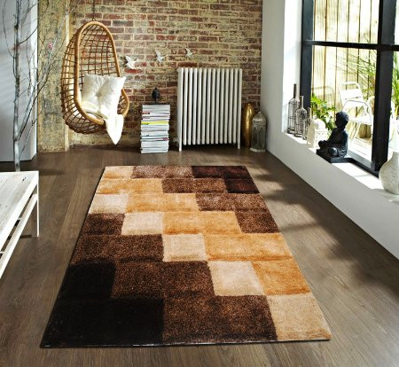

Flooring India 3D Blocks Carpet - 150 x 230 cms, Beige
by Flooring India
Be the first to review this item

Available from these sellers.
1 offer from 11,603.00

Size: 150 x 230

- 120 x 180 from 6,863.00

- 150 x 230 from 11,603.00
- 90 x 150 from 4,540.00

- Color: Beige
- Material: Polyester
- Pattern: Modern
- Size: 150 x 230

- 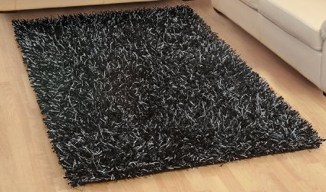

Flooring India Polyester Carpet (Shimmer_Black_Close Up, 80 Cms X 150 Cms)
by Flooring India
Be the first to review this item

Price: | 9,046.00 FREE Delivery.Details
 | Inclusive of all taxes
EMI starts at 807.96 per month. Options

Only 1 left in stock.
Sold by LUXEHOME INTERNATIONAL and Fulfilled by Amazon. Gift-wrap available.
- Material: Polyester
- Colour: Black
- Dimensions: 80 cms x 150 cms
- Pattern: Modern
- Package Contents: 1 Carpet

- 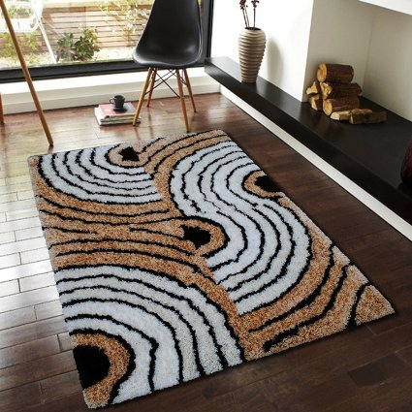

Flooring India Polyester Carpet (Comfort-Retro_Beige, 57 Cms X 140 Cms)
by Flooring India
Be the first to review this item

Available from these sellers.
1 offer from 2,900.00
Top of Form
Size: 57 cms x 140 cms
- 57 cms x 140 cms from 2,900.00

- 80 cms x 150 cms from 4,360.00
- 120 cms x 170 cms from 7,412.00
- 150 cms x 230 cms from 12,535.00

Bottom of Form
- Material: Polyester
- Colour: Beige
- Dimensions: 57 cms x 140 cms
- Pattern: Modern
- Package Contents: 1 Carpet

- 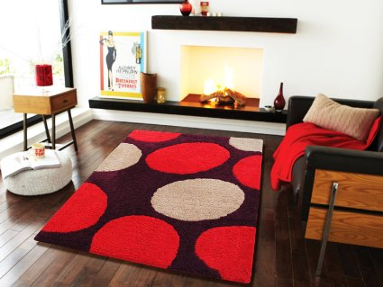
- Flooring India Polyester Carpet (Sensuous-Retro_Red, 57 Cms X 140 Cms)
by Flooring India
Be the first to review this item

Price: | 6,016.00 FREE Delivery.Details
 | Inclusive of all taxes
EMI starts at 537.33 per month. Options
Only 1 left in stock.
Sold by LUXEHOME INTERNATIONAL and Fulfilled by Amazon. Gift-wrap available.
- Material: Polyester
- Colour: Red
- Dimensions: 57 cms x 140 cms
- Pattern: Modern
- Package Contents: 1 Carpet

- 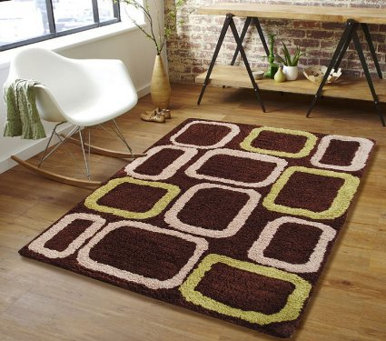

Flooring India Polyester Carpet (Sensuous-Boxes_Chocolate, 57 Cms X 140 Cms)
by Flooring India
Be the first to review this item

Price: | 6,016.00 FREE Delivery.Details
 | Inclusive of all taxes
EMI starts at 537.33 per month. Options
Only 1 left in stock.
Sold by LUXEHOME INTERNATIONAL and Fulfilled by Amazon. Gift-wrap available.
- Material: Polyester
- Colour: Chocolate
- Dimensions: 57 cms x 140 cms
- Pattern: Modern
- Package Contents: 1 Carpet

